**Practical Activity 5**

**Windows Server Administration**



**Name**: Lamis Mohamed GabAllah

**Email**: [lamis.mohammed@womentechsters.org](mailto:lamis.mohammed@womentechsters.org)

**Date**: 19th June 2021

**Practical Activity 5**

Assuming you are a system administrator in “CarMax” Car Dealership and you have been assigned with a task to add 1 Headquarters and 2 Sales Locations in a windows Server 2016 you configured.

1. With the help of Active Directory, Add the Headquarters and 2 Sales Locations.

**Headquarters has:**

* Administrative Dept
* Accounting Dept
* Hr

**Each Sales Location has:**

* Sales Staff
* Mechanic Staff
* Management

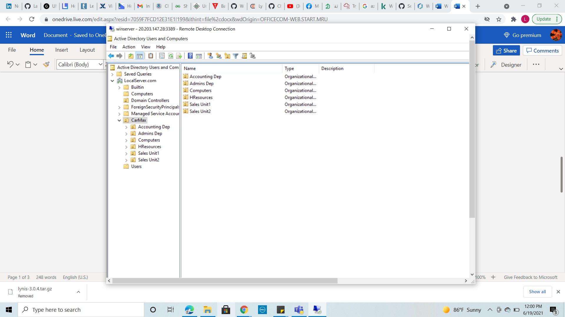

1. Under each Unit add dummy users.

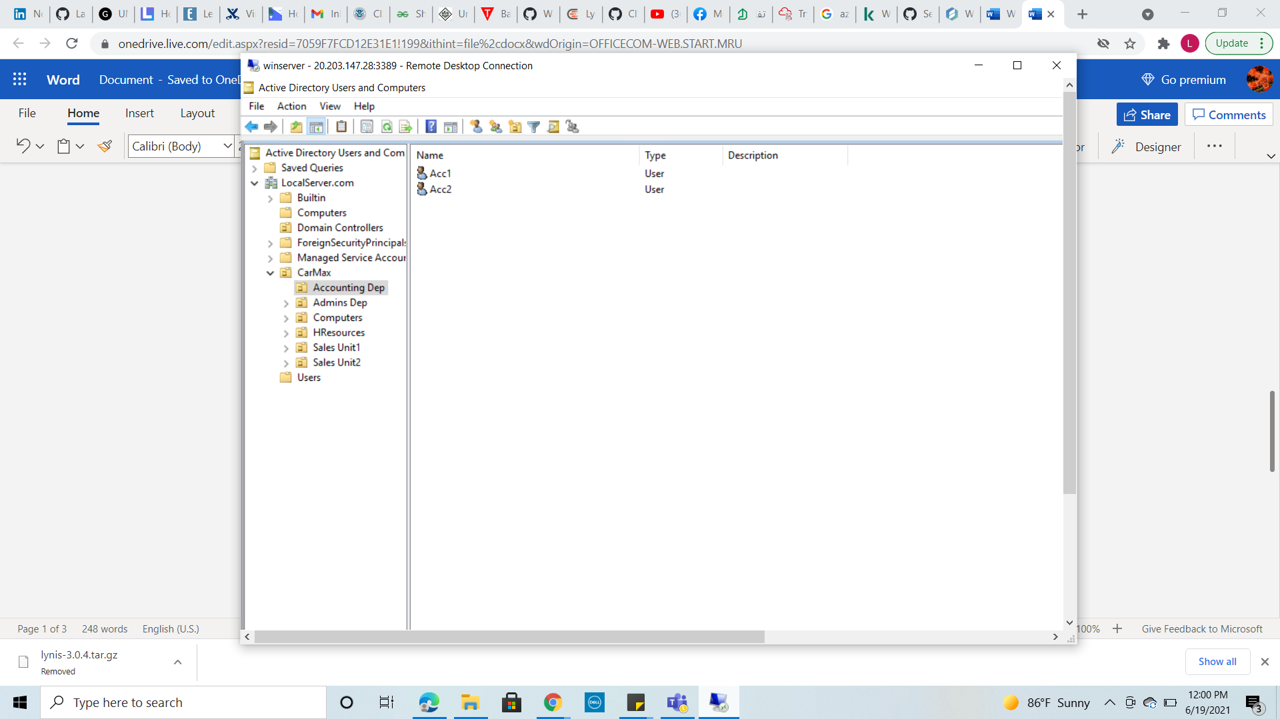

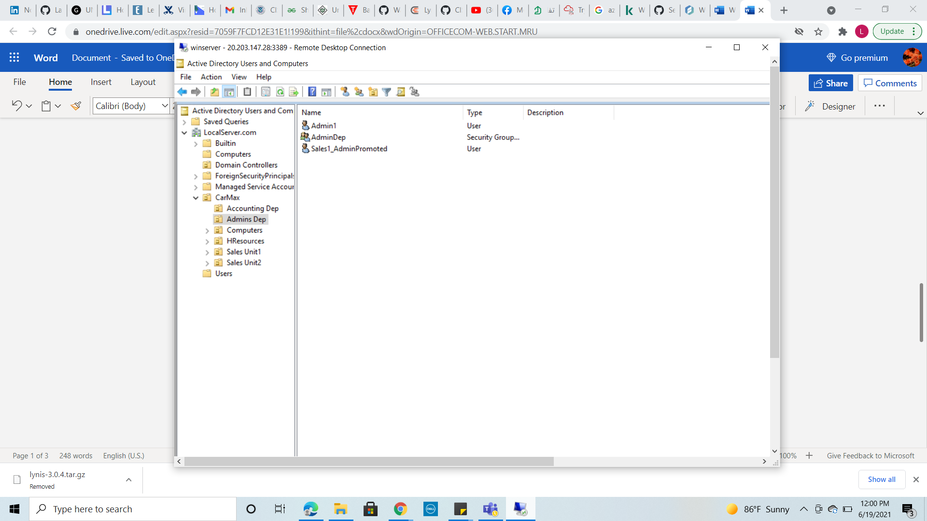

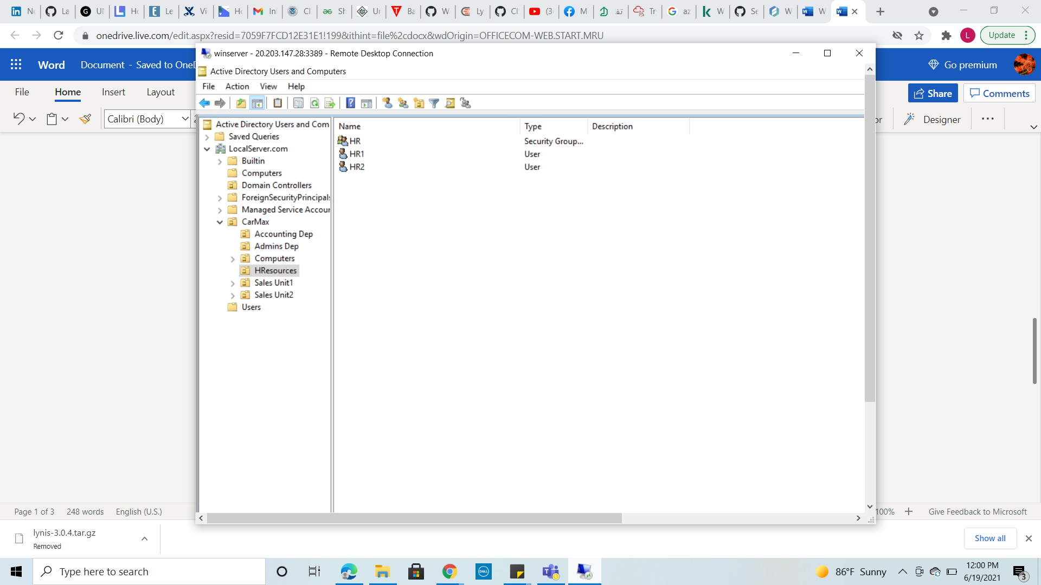

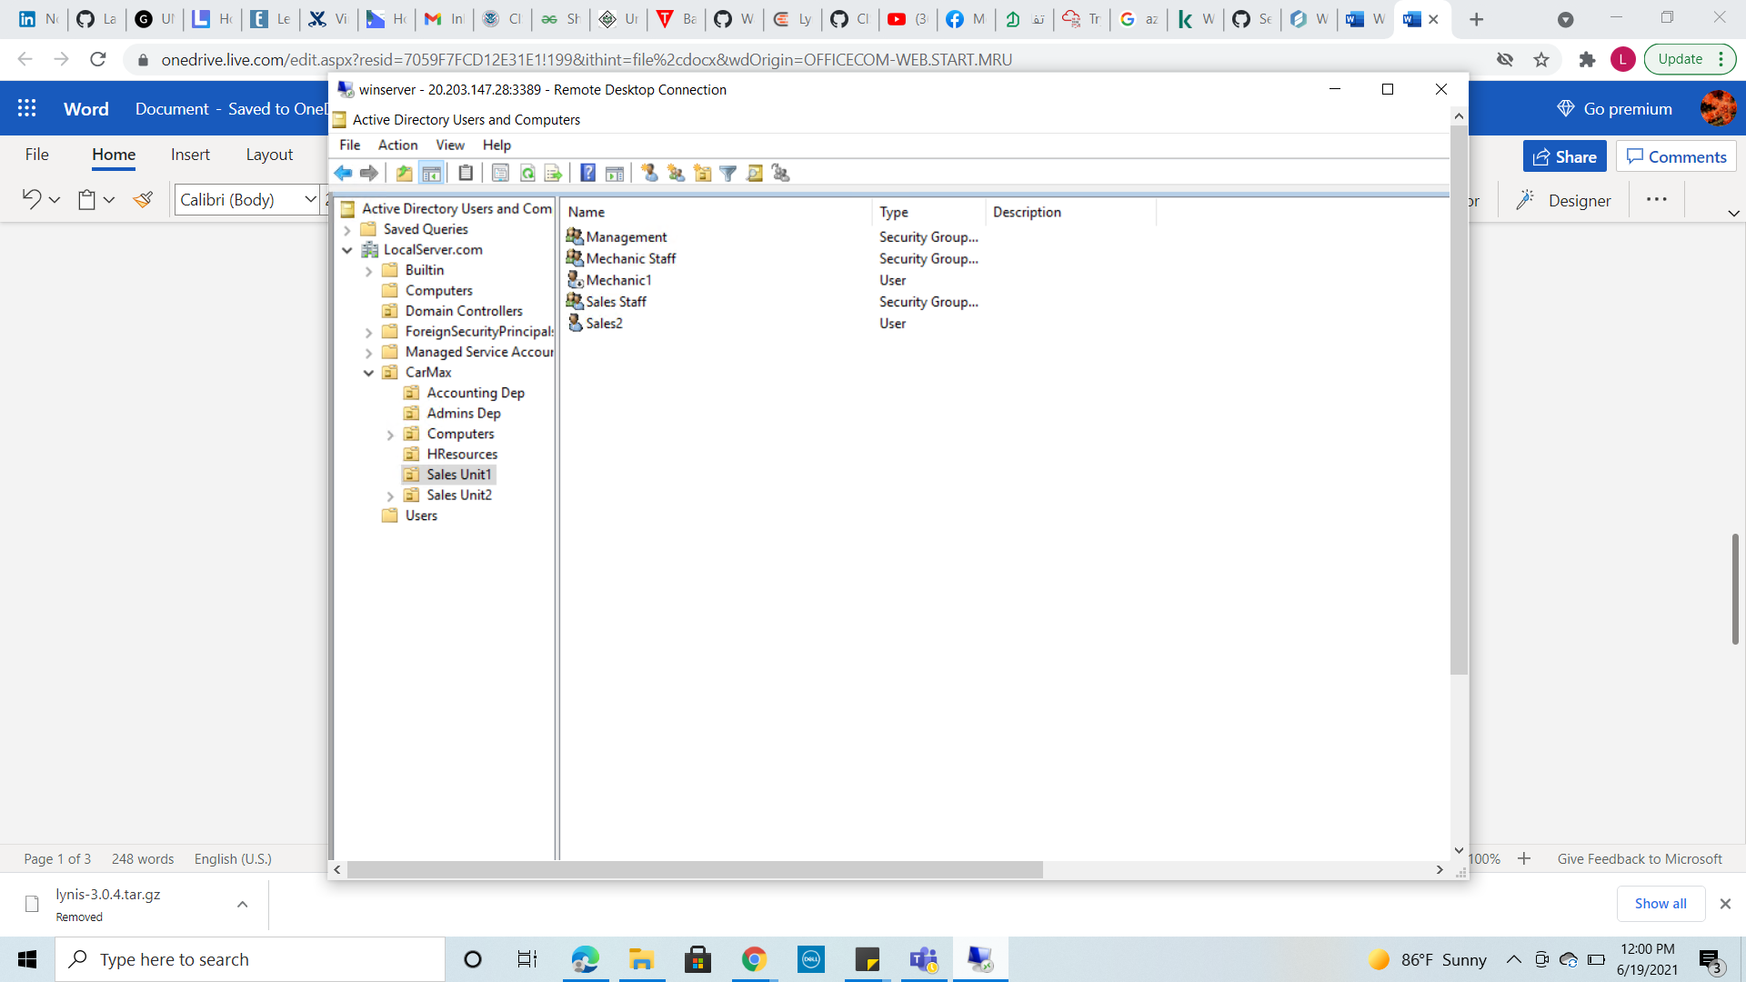

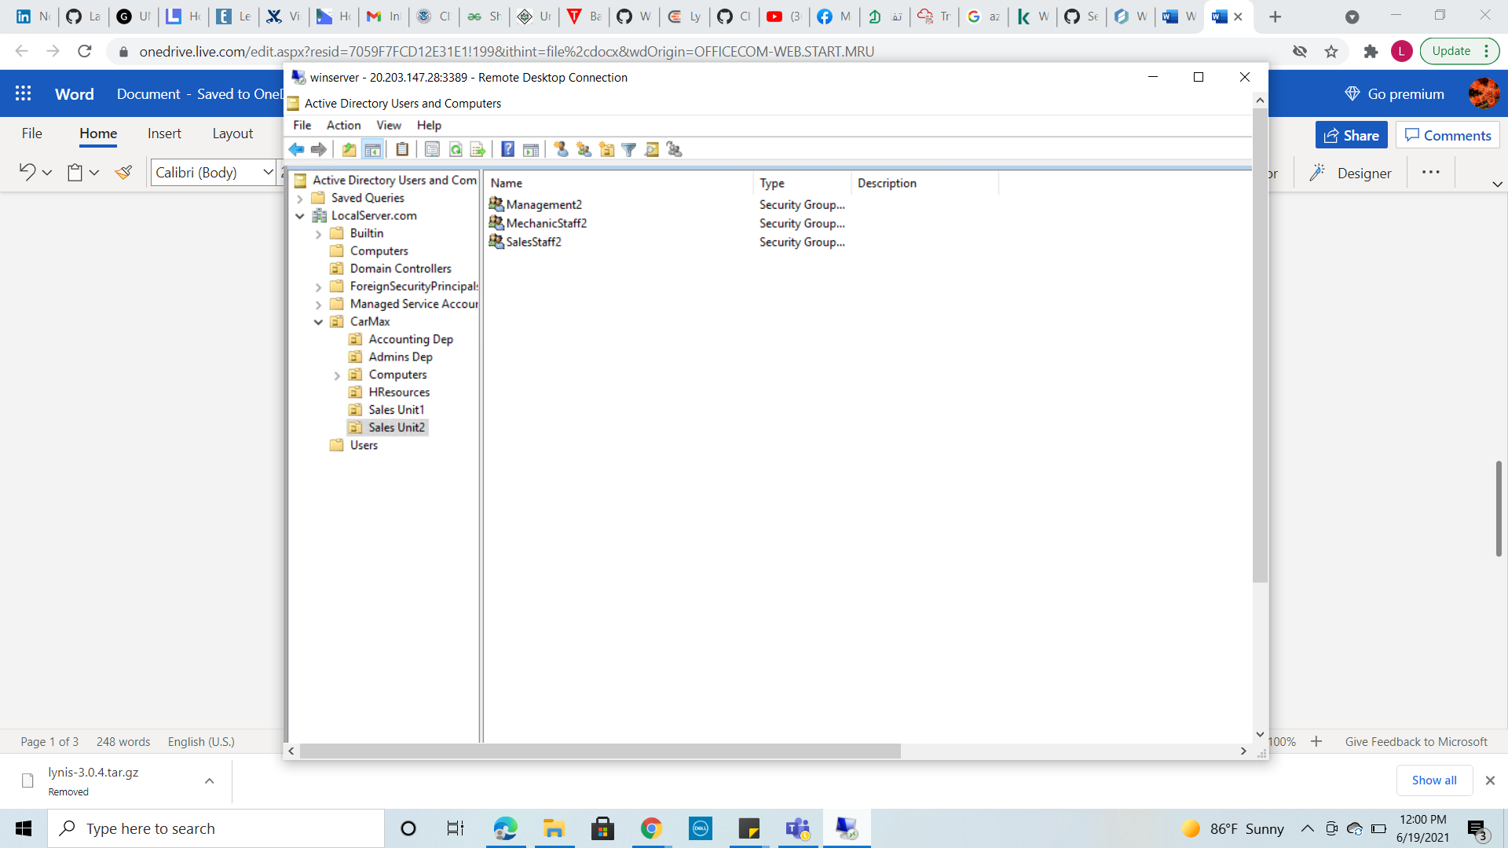

1. Assuming a user in Sales Staff is promoted to Administrative Dept, give a description on how you will handle this and make sure the **sales user is effectively transitioned to Administrative Unit**. Please give a detailed description with accompanied screenshots.

* 3-A-right click on the Sales user
* 3-B-click on “Move

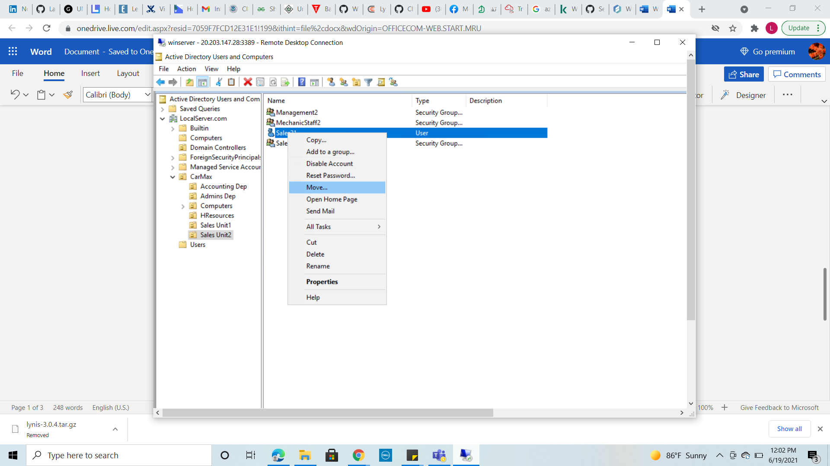

* 3-C the below Tree appeared to select the Department at which the user will be transferred to , select “Admin Dep” from the tree.

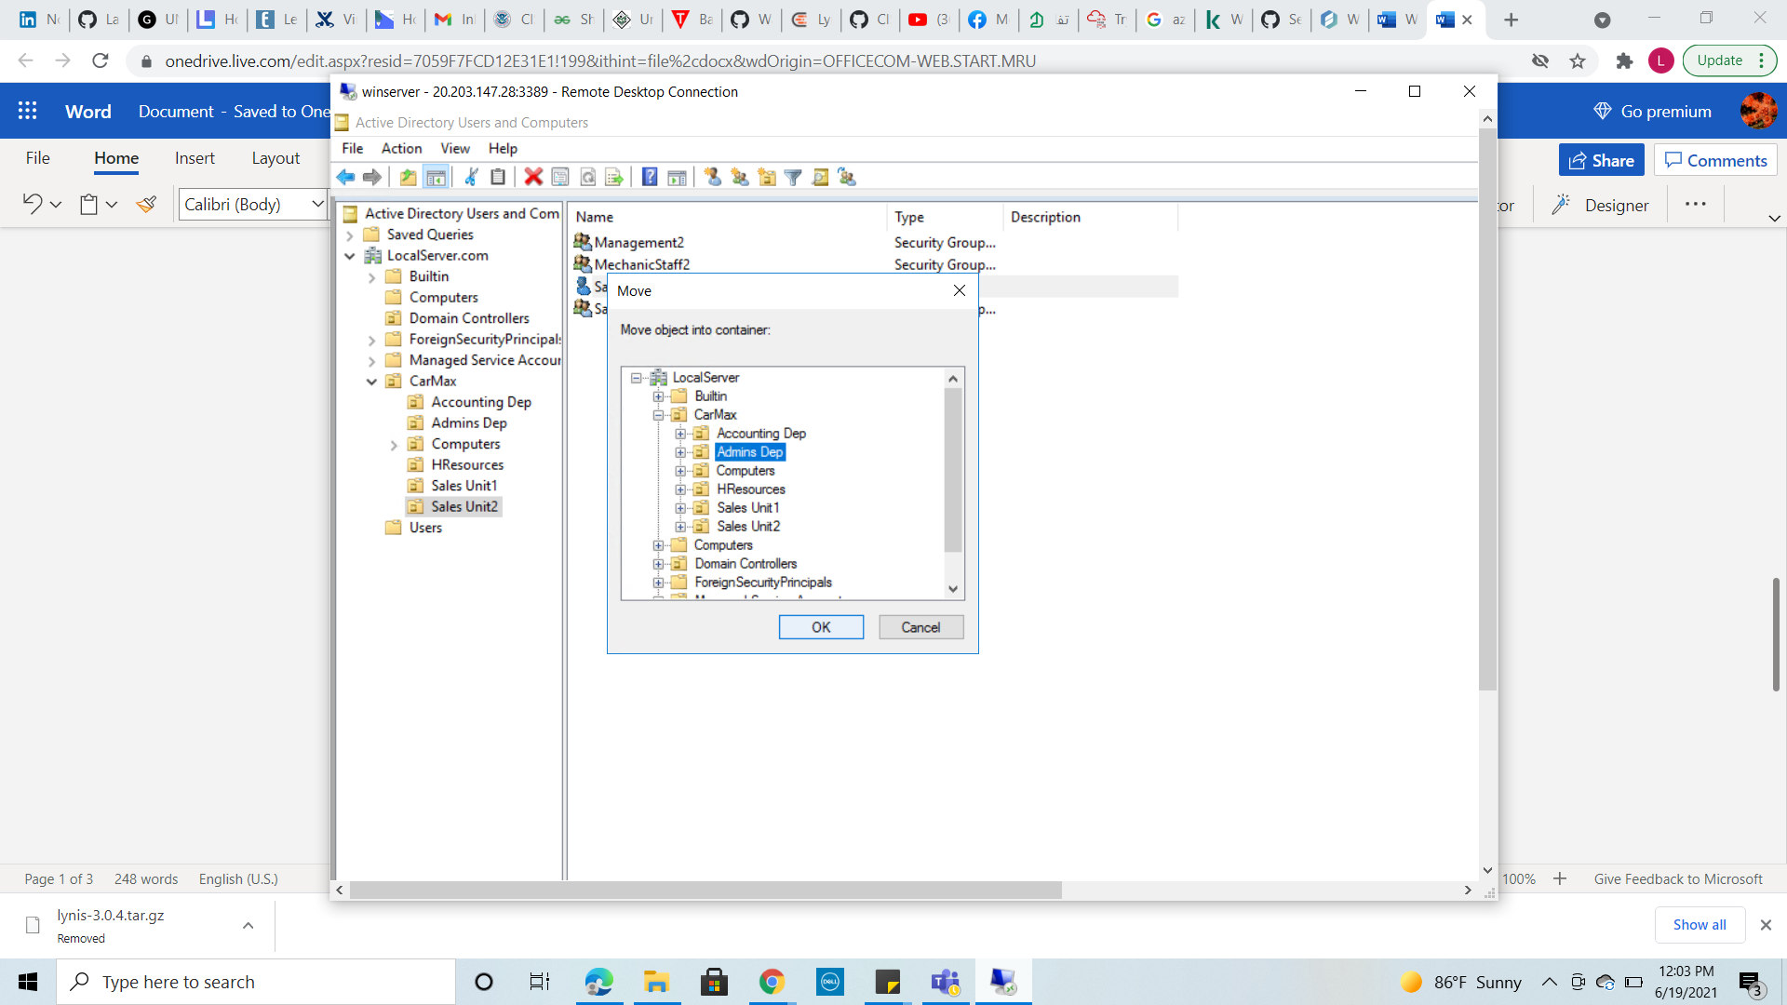

* 3-D right click on the user Sales1 rename it to “Sales1-AdminPromoted”, and right click again select “Properties” , and press on “Member of “ tab to add the user to the suitable group under Admin Dep.
* 3-E Click on “AdminDep” Group and click on “Set Primary Group” option in the bottom of the wizard , then Click on Sales “Sales staff” group and click on “Remove “button, to transfer the user to it’s new promoted group.

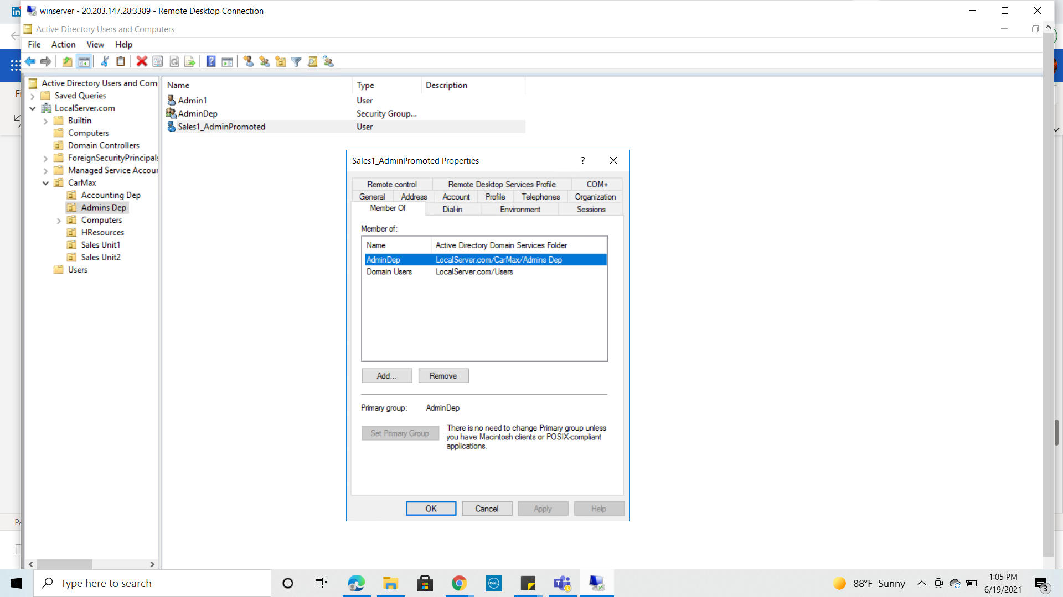

1. Assuming “One dummy” user in Mechanic Staff has gone on leave for one month, give a detailed description of how you will ensure **their user account is inactive and cannot be accessed by any other person during this one-month leave.** This is to ensure unauthorized users to do not use that account to access the organization system.

* 4-A right click on the Mechanic1 user and select “Disable” to disable the account., and right click again “Enable Account” option appears that means its disabled now successfully.

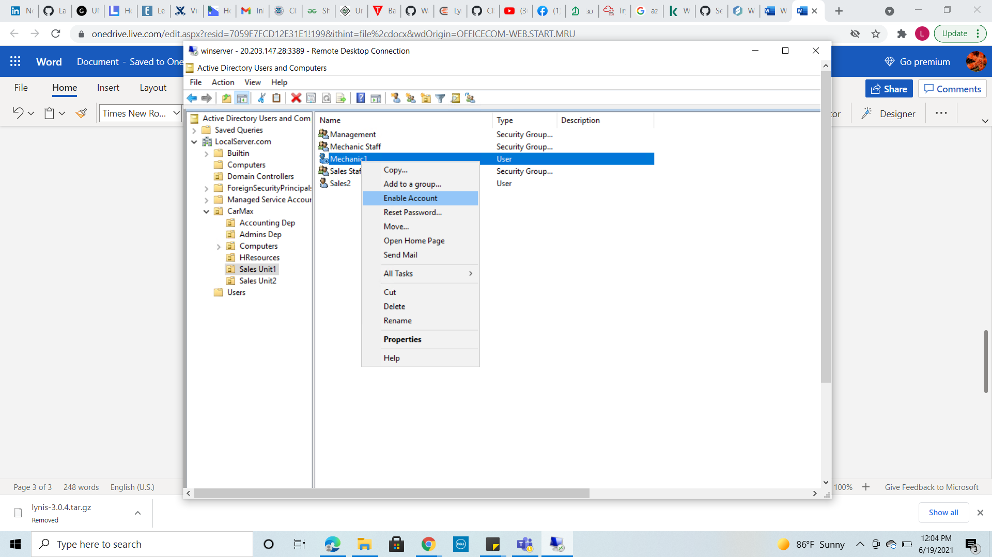

1. In accounting Dept, we want to maintain high notes of security especially to the computers. **Add a computer policy under Accounting Dept** to ensure all computers are locked or disabled after 3 minutes of inactivity. The user has to login once again when back.

* 5-A from the Server Manager click on “Tools” and select “GrouPolicy Management”

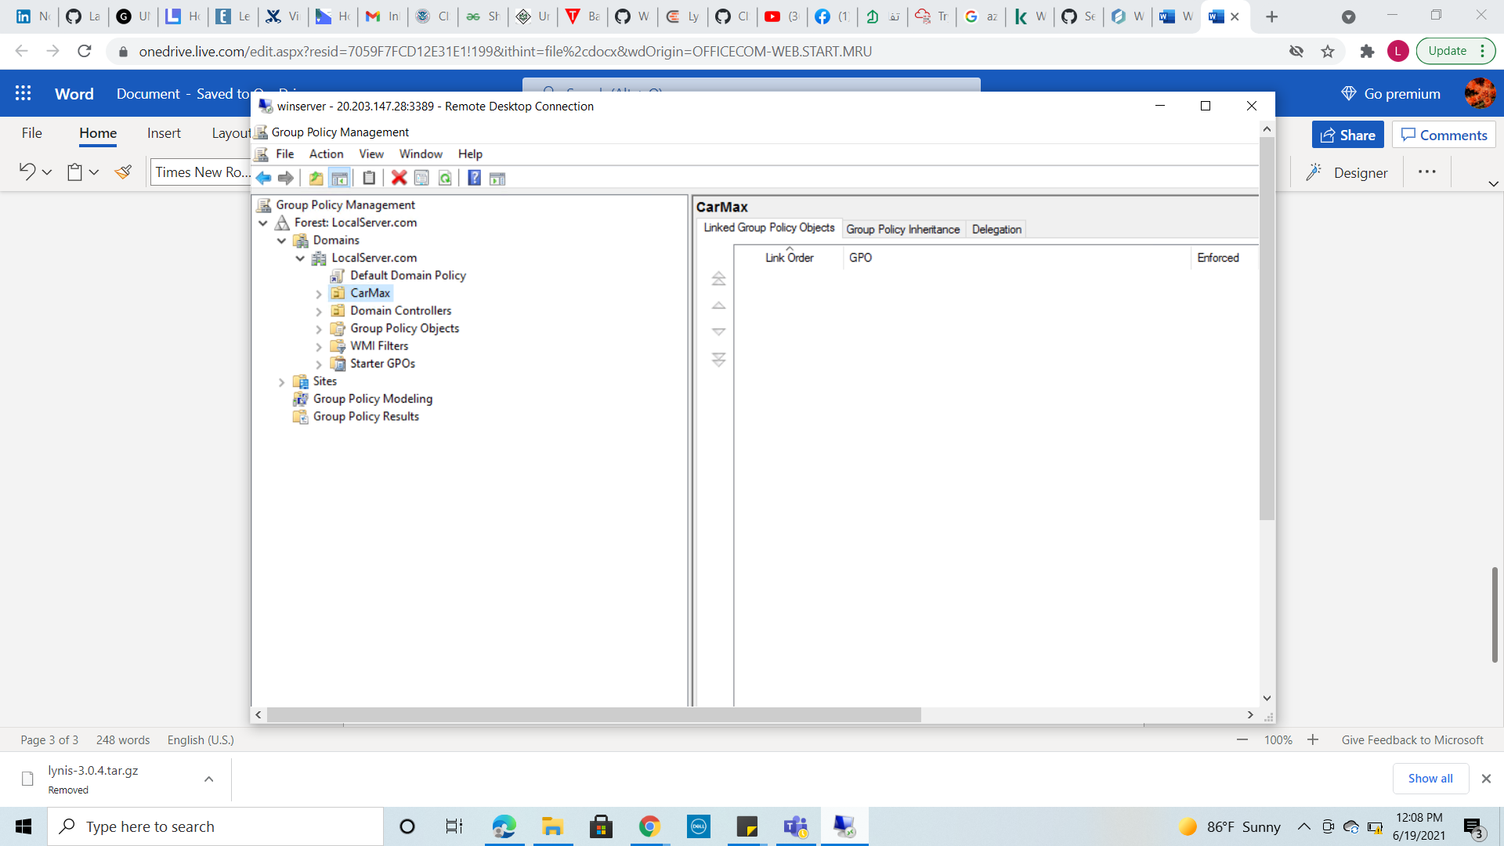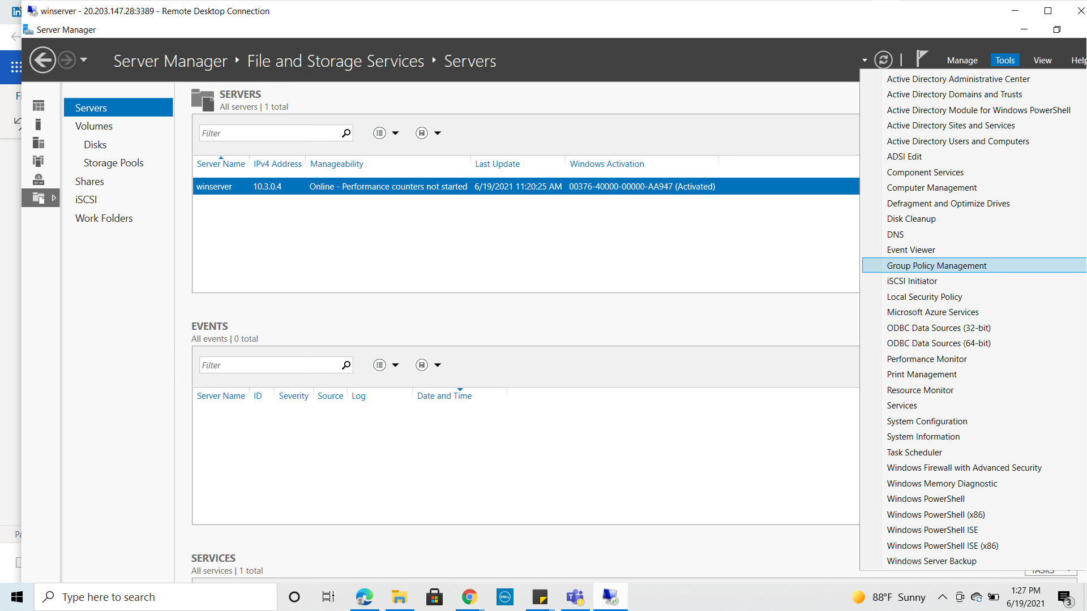

* + 5-B the below window opened after clicking on “Group policy management” , right click the “Accounting Dep” and select “Creat GPO in this domain, and link it here” to create the group policy.

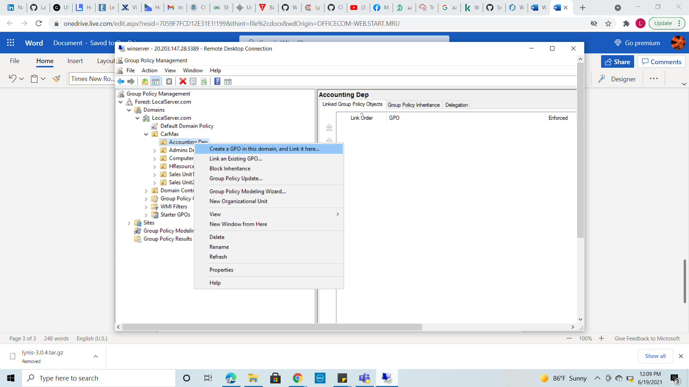

* + 5-c the below wizard appeared to enter the Group Policy Name , “Timeout3”

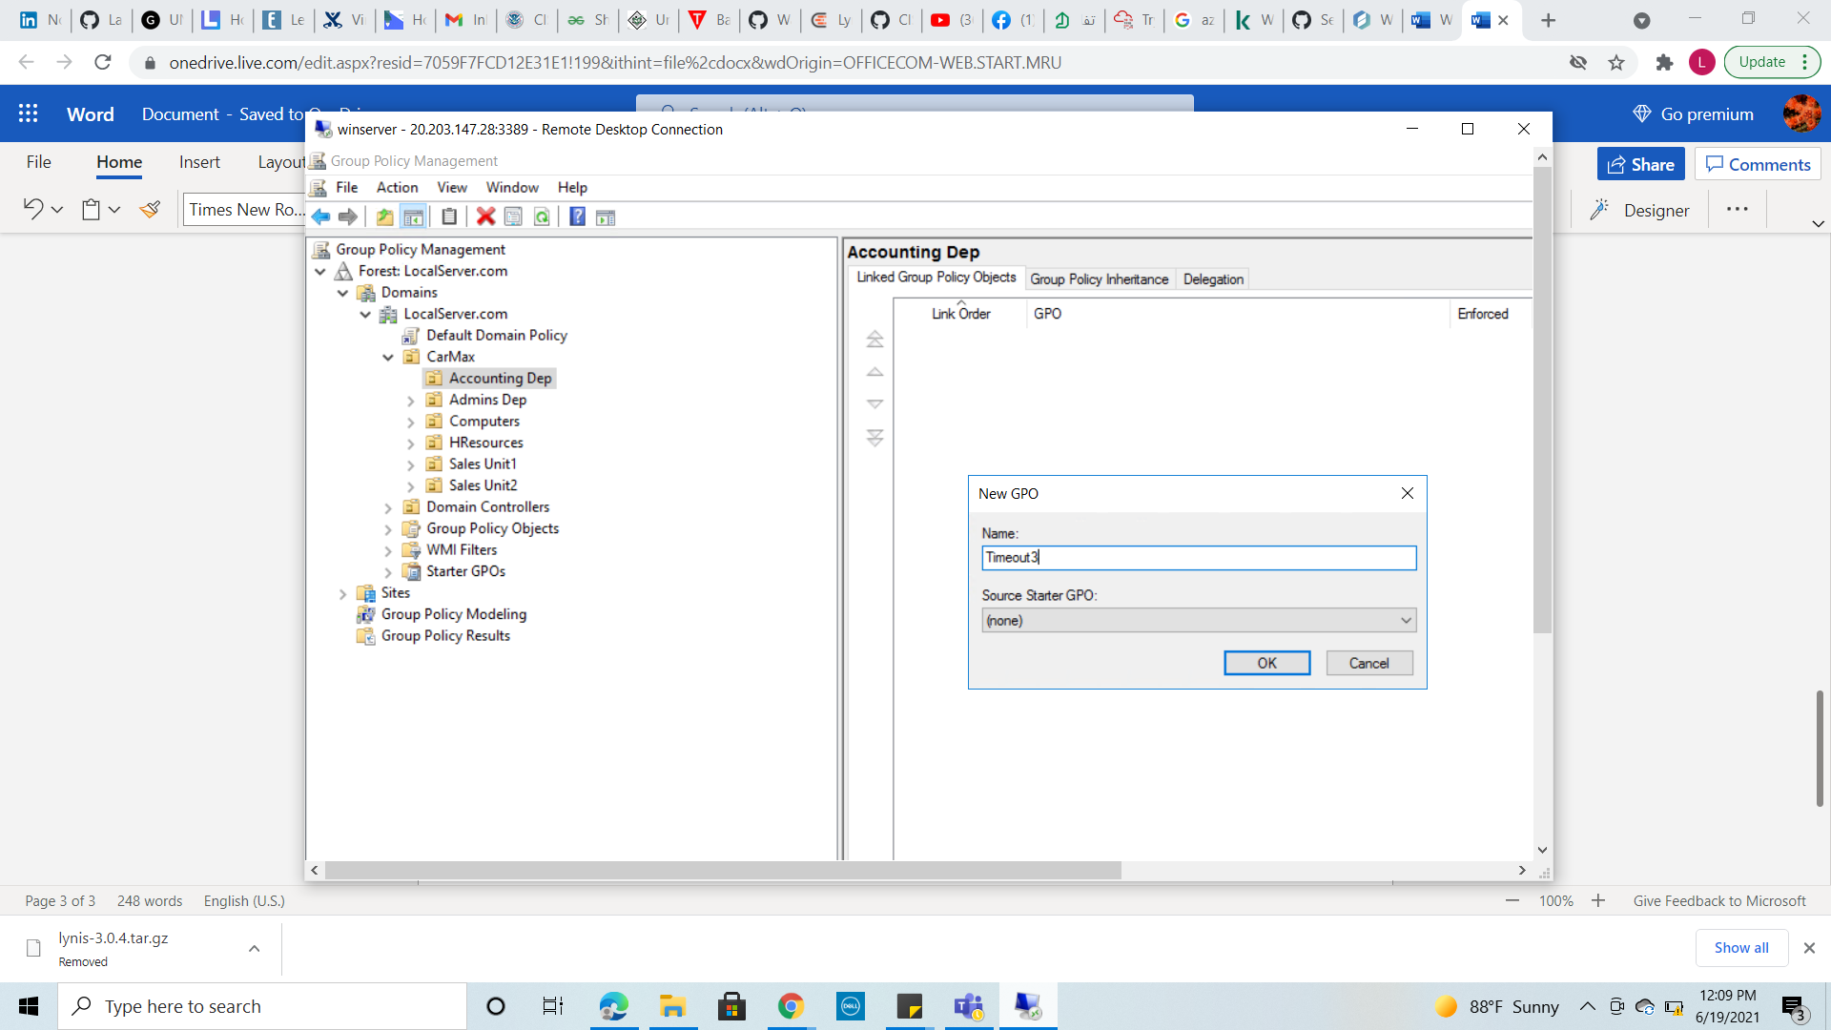

* + 5-D after creating the Group policy the below window appeared,press on “setting” tab then right click and select “Edit”

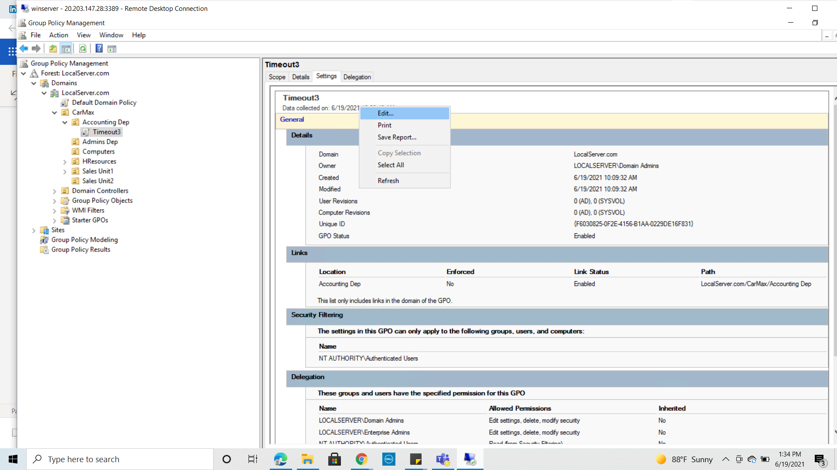

* + 5-E the below window appeared , under “Computer Configuration” click on “Policies”

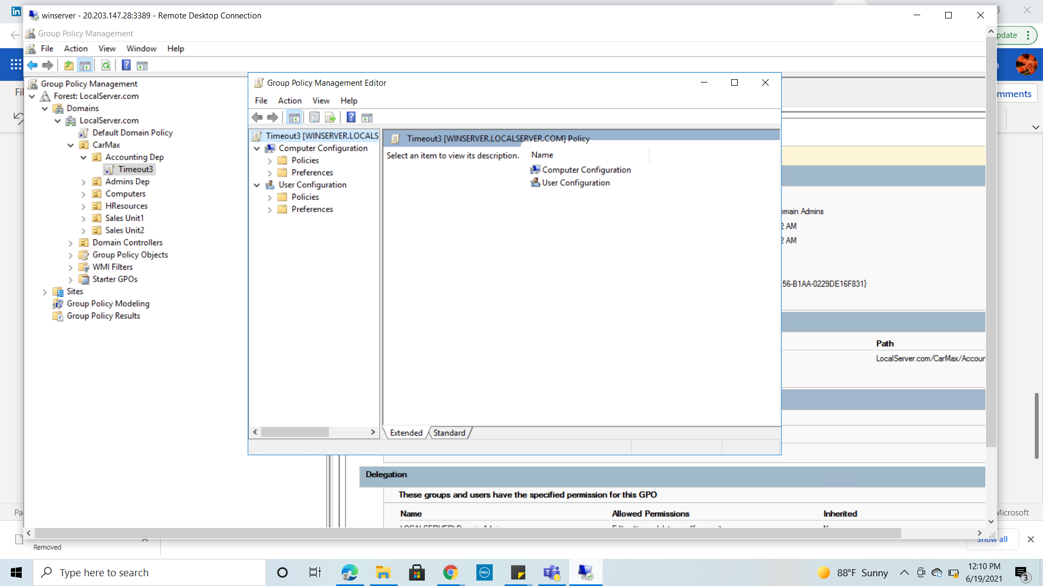

* + 5-F press under Policies >>Windows settings >>Security Settings>>local Policies>>Security Options to display all the available Policies

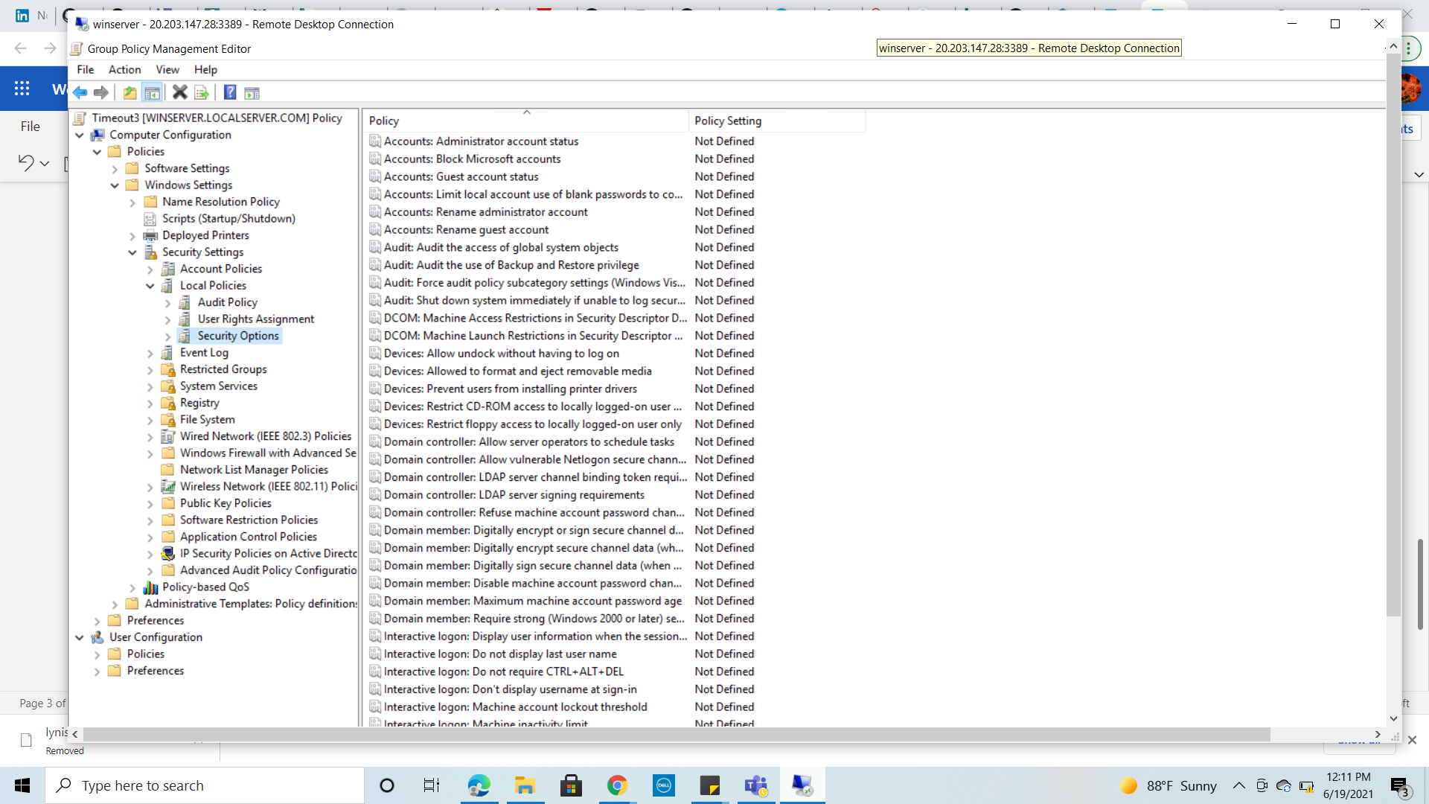

* + 5-G click Machine activity limit policy to set the seconds to 160 = 3 minutes

